**Chaorai Prompt**

Introduction to Software Engineer 95303 Project

Team name: Untitled

|  |  |
| --- | --- |
| Kan Katpark | Project manager, Software Architecture & Analyst |
| Jakkaphat Polylake | Software Designer & Tester |
| Dusit Chunviset | Software Designer & Tester |
| Tinnapat Rattanawilaikul | Software Designer & Analyst |
| Sarin Patanompee | Software Tester & Architecture |

### 

# Project detail

### Ideas

A software project (Mobile Web Application) that aims to create a centralized market for farmers to list agricultural products for free. Which farmer can sell their products at prices as high as they want them to be. The company will take a percentage cut from the listed price of the sold products.

## User research

### Background

* **Problem**
* Middleman exploits farmers in Thailand.
* Farmers can't find the market to sell their products.
* **Purpose**
* Aim to be a place where Thai farmers can freely sell their products.
* **Scope**
* Thai farmer

### Project vision statement

**For** Thai farmers

**WHO** want to sell their products at a fair price

**THE** Chaorai Prompt is an E-Commerce mobile web application

**THAT** aims to be a new open market of agricultural products

**UNLIKE** other e-commerce because we focus on agricultural products.

### Perspectives

* User
* Farmer
* Admin

### Feature:

**Everyone:**

* Chat
* Payment
* Authentication
* Authentication with third-party
* Register
* Share product
* Update self-information
* 2 Factor Authentication
* Report product

**User:**

* Buy product
* Check order status
* Confirm receive order
* Comment and Rate the product
* Open store

**Farmer:**

* Add and remove their products
* Update product and order status
* Check and withdraw money
* Can use user’s feature

**Admin:**

* Approve the open store request
* Ban most report product
* Manage user account

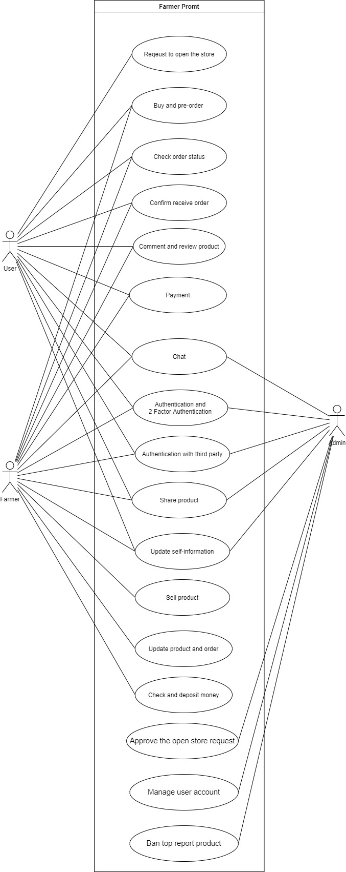Use Case diagram

## 

## Use case description

|  |  |
| --- | --- |
| **Use case Name** | Register |
| **Description** | 1. Enters email and password  2. Hit sign up |
| **Actor** | Everyone |

|  |  |
| --- | --- |
| **Use case Name** | Register with third-party |
| **Description** | 1. Hit register with third-party |
| **Actor** | Everyone |

|  |  |
| --- | --- |
| **Use case Name** | Login |
| **Description** | 1. Enters username and password into the login form  2. Hit login button  3. 2FA if the user had added telephone number |
| **Actor** | Everyone |

|  |  |
| --- | --- |
| **Use case Name** | Login with third-party |
| **Description** | 1. Hit login with third-party  2. 2FA if the user had added telephone number |
| **Actor** | Everyone |

|  |  |
| --- | --- |
| **Use case Name** | Update self-information |
| **Description** | 1. Hit edit profile button  2. Edit  3. Hit update button |
| **Actor** | Everyone |

|  |  |
| --- | --- |
| **Use case Name** | Add 2-factor authentication |
| **Description** | 1. User hit adds phone number button  2. User enters their phone number  3. User hit send OTP button  4. Enter OTP code  5. Submit |
| **Actor** | Everyone |

|  |  |
| --- | --- |
| **Use case Name** | Report Product |
| **Description** | 1. Hit report button  2. Select report topic  3. Hit submit |
| **Actor** | Everyone |

|  |  |
| --- | --- |
| **Use case Name** | Share product |
| **Description** | 1. Hit share button  2. Select platform to share |
| **Actor** | Everyone |

|  |  |
| --- | --- |
| **Use case Name** | Send a message |
| **Description** | 1. Hit the “Chat” button  2. Select other users  3. Text a message  4. Hit “send” button |
| **Actor** | Everyone |

|  |  |
| --- | --- |
| **Use case Name** | User adds the product to their cart |
| **Description** | 1. Select product  2. Hit buy/preorder button  3. Product is added to the cart |
| **Actor** | User |

|  |  |
| --- | --- |
| **Use case Name** | User checkout and payment |
| **Description** | 1. Hit checkout button  2. Confirm product list  3. Select payment method  4. Confirm address  5. Checkout |
| **Actor** | User |

|  |  |
| --- | --- |
| **Use case Name** | User check their order status |
| **Description** | 1. Hit my order button  2. Select order which they want to check |
| **Actor** | User |

|  |  |
| --- | --- |
| **Use case Name** | User confirm receive product |
| **Description** | 1. Hit my order button  2. Select order which they want to confirm  3. Hit confirm receive button |
| **Actor** | User |

|  |  |
| --- | --- |
| **Use case Name** | User review product |
| **Description** | 1. Give star rate  2. Write comment  3. Hit submit button |
| **Actor** | User |

|  |  |
| --- | --- |
| **Use case Name** | User asks to open the store |
| **Description** | 1. Hit “sale your product” button  2. Enter their information.  3. Hit submit button |
| **Actor** | User |

|  |  |
| --- | --- |
| **Use case Name** | Farmers edit their information |
| **Description** | 1. Hit “my store” button  2. Hit edit store  3. Update their information  4. Hit submit |
| **Actor** | Farmer |

|  |  |
| --- | --- |
| **Use case Name** | Farmers check their product |
| **Description** | 1. Hit “my product” button  2. Check their product status |
| **Actor** | Farmer |

|  |  |
| --- | --- |
| **Use case Name** | Farmers add their product |
| **Description** | 1. Hit “my product” button  2. Hit add product  3. Fill in the new product information  4 Hit submit |
| **Actor** | Farmer |

|  |  |
| --- | --- |
| **Use case Name** | Farmers update their product |
| **Description** | 1. Hit edit product button  2. Update the information  3. Hit submit |
| **Actor** | Farmer |

|  |  |
| --- | --- |
| **Use case Name** | Farmers delete their product |
| **Description** | 1. Hit delete product button  2. Hit confirm |
| **Actor** | Farmer |

|  |  |
| --- | --- |
| **Use case Name** | Farmers check their sale order |
| **Description** | 1. Hit “sale order” button |
| **Actor** | Farmer |

|  |  |
| --- | --- |
| **Use case Name** | Farmers update their sale order |
| **Description** | 1. Hit “sale order” button  2. Hit “On delivery” button |
| **Actor** | Farmer |

|  |  |
| --- | --- |
| **Use case Name** | Farmers deposit money |
| **Description** | 1. Hit “My wallet button” button  2. Select bank account to receive money  3. Hit submit  4. Do OTP verification |
| **Actor** | Farmer |

|  |  |
| --- | --- |
| **Use case Name** | Farmers check their money |
| **Description** | 1. Hit “My wallet button” button  2. Select “History” menu |
| **Actor** | Farmer |

|  |  |
| --- | --- |
| **Use case Name** | Admin approve store |
| **Description** | 1. Hit manage Store button  2. Select the request store in list  3. Hit approve or cancel |
| **Actor** | Admin |

|  |  |
| --- | --- |
| **Use case Name** | Admin ban top report product |
| **Description** | 1. Hit manage product button  2. Read the information  3. Hit Ban button  4. The auto message will be sent to the product owner |
| **Actor** | Admin |

|  |  |
| --- | --- |
| **Use case Name** | Admin manage user |
| **Description** | 1. Hit manage user |
| **Actor** | Admin |

## 

## Sketch Design

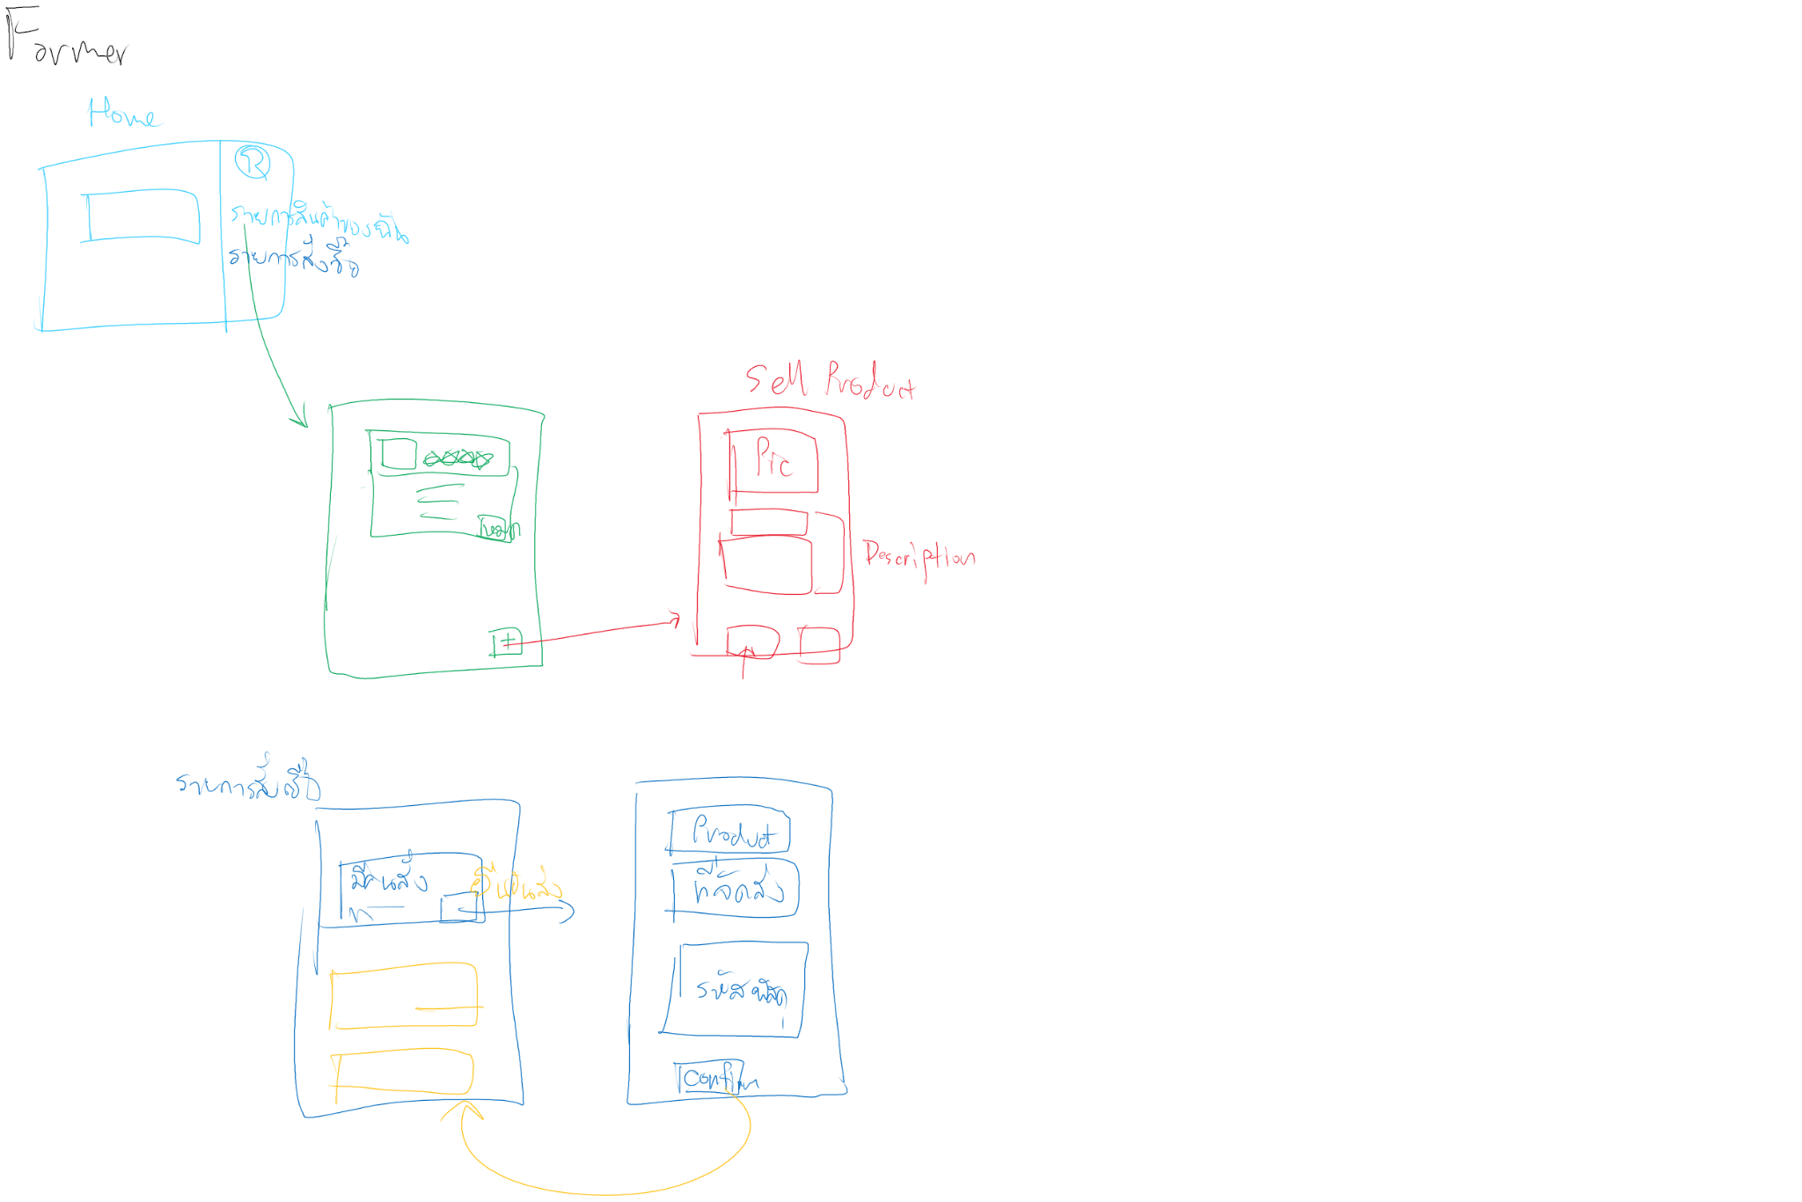

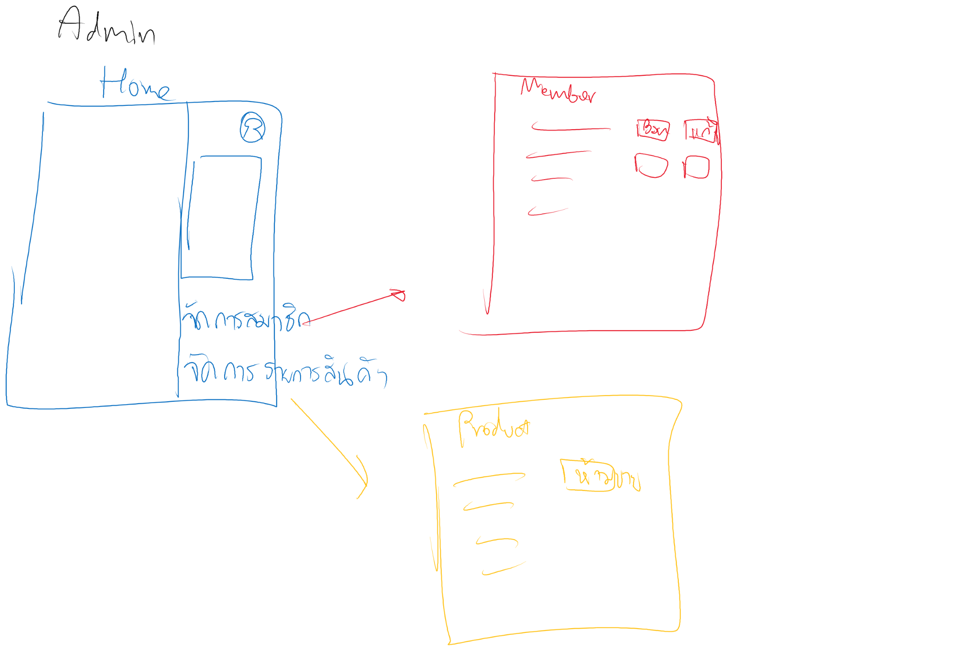

## Architecture

RESTFUL web and mobile web application that is deployed with docker on the cloud server.

### Technology

#### Frontend: NextJS

NextJS is a Javascript framework that is an upgraded version of ReactJS. NextJS can work in SEO easier than ReactJS and NextJS also can do SSG, ISR, CSR, and SSR that is the reason why we chose NextJS.

#### Backend: TypeScript

Typescript is chosen to use on the server-side to receive the request and send the response and also work with authentication. The libraries that we will use are Express and JSONWebtoken.

#### Database: MongoDB

MongoDB is a document-based database and it is horizontally scalable. 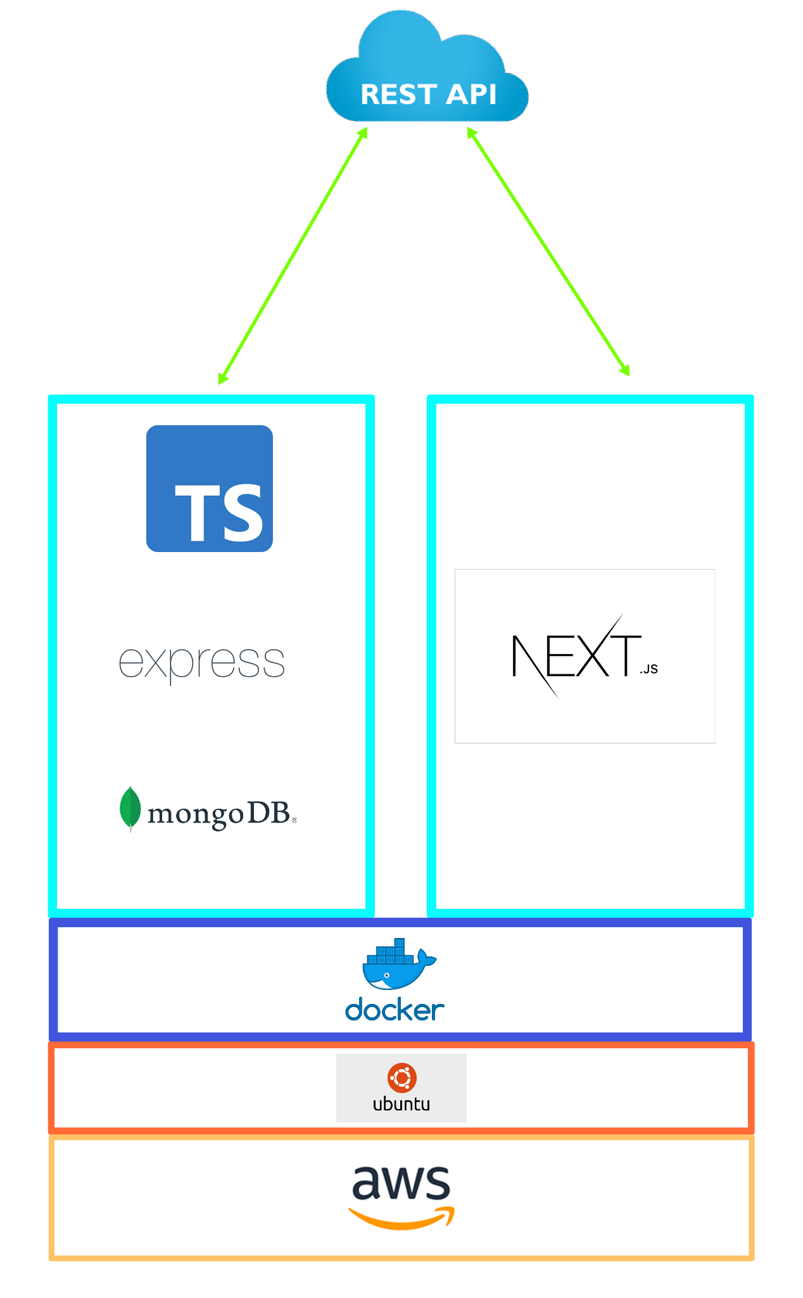

#### Tool

* Git
* Docker
* Discord
* Adobe XD
* Amazon AWS

## **Software process model**

**Extreme Programming**

“Extreme Programming is a lightweight methodology for small to medium-sized teams developing software in the face of vague or rapidly changing requirements”

Kent Beck

From the definition, XP is suitable for our team that have 5 peoples and the requirements or feature can be changed or added any time. And our team members can work separately for 24 hours by leaving a message or today's progression in discord and other members can continuously work on it.

## Project Timeline

|  |  |  |  |  |
| --- | --- | --- | --- | --- |
| Task name | Duration (day) | Start date (d/m) | End date (d/m) | Responsibility |
| Project launch | 1 | 27/01 | 27/01 | Everyone |
| Select topic and scope of software project | 2 | 28/01 | 29/01 | Everyone |
| Use research and product vision | 1 | 30/01 | 30/01 | Everyone |
| List of features | 1 | 31/01 | 31/01 | Everyone |
| Select software architecture and technology | 1 | 01/02 | 01/02 | Kan  Sarin |
| Create a use case diagram | 18 | 02/02 | 20/02 | Jakkapat Tinnapat |
| Create a use case description | 18 | 02/02 | 20/02 | Tinnapat  Dusit |
| Create sketch design | 1 | 02/02 | 02/02 | Everyone |
| Implement software prototype #1 | 6 | 03/02 | 09/02 | Tinnapat  Jakkapat  Dusit Kan |
| Hybrid meeting | 1 | 09/02 | 09/02 | Everyone |
| Fix list of feature and requirement | 1 | 09/02 | 09/02 | Everyone |
| Implement software prototype #2 | 7 | 09/02 | 16/02 | Tinnapat  Jakkapat  Dusit Kan |
| Test #1 User feature | 3 | 14/02 | 17/02 | Sarin |
| Fix test #1 | 4 | 17/02 | 21/02 | Tinnapat  Jakkapat  Dusit |
| Test #2 Farmer feature | 3 | 19/02 | 22/02 | Sarin |
| Fix test #2 | 1 | 22/02 | 22/02 | Tinnapat  Jakkapat  Dusit |
| Test #3 Admin feature | 1 | 22/02 | 23/02 | Sarin |
| Fix test #3 | 1 | 23/02 | 23/02 | Tinnapat  Jakkapat  Dusit |

# **Usability testing**

Prototype name: Chaorai Prompt 0.1

Feature list: Whole feature

Number of participants: 2 people

*Before test UI*

** 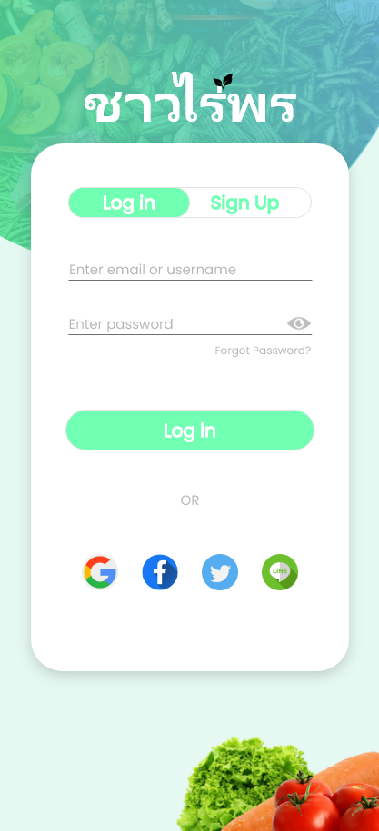 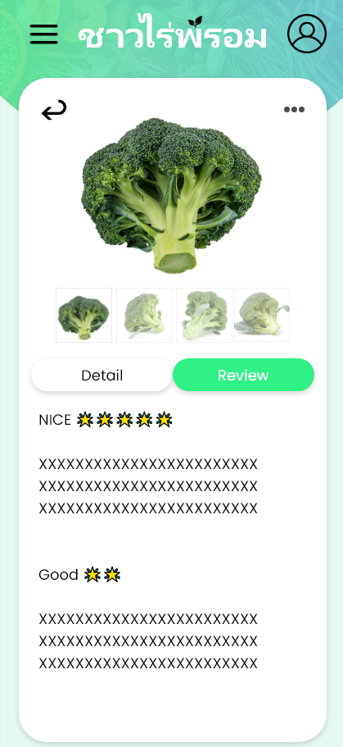 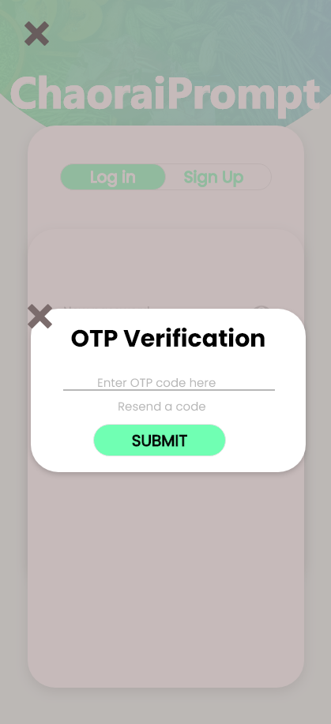

Context (User, task, environment):

User: 2 Students

Task: Test the basic functions for

#1 Users,

#2 Farmers,

#3 Administrators,

and point out design flaws.

Environment:

#1 User

#2 Farmer

#3 Administrators

Techniques (Think aloud/Observation/Interview): Think Aloud

**Results**

**User feedbacks**

**User** Part:

In general. The UI lacks conciseness. Clarity could be better; more information needs to be presented. The PromptPay function is too hard to use.

Texts need to have more contrast with the backgrounds, text cut-off. Ease of use could be better on the home screen; 2 products per screen is too low. Sidebars come up when you don’t want them to. The star in the star rating is straight up an emoji, and needs to be replaced. Inconsistent back/return button; sometimes an arrow, sometimes an x.

**Farmer** Part:

There are a lot of misaligned icons and UI elements. The UI doesn’t have proper margin/padding. The Sale Order descriptions don’t give enough information at a glance and go against basic color signals. Icons can be misinterpreted and need to be replaced with better ones.

Transaction history needs to give more information, better color coding, clear symbols.

A lot of buttons could be repositioned into many pages, such as profile, to avoid cluttering the sidebar.

Page for financials needs to be redone to display relevant information and not a huge cash icon.

**Administrator** Part:

Sidebar icon needs a notification icon.

Images here don’t have rounded edges despite most of the UI having rounded edges. Inconsistent color scheme.

Text cut-off, Lack of color variety.

Lack of search function in User Page; There could be like thousands of users, possibly, in that page.

Term of Uses pop-up needs to have a smaller font size for texts.

The Chat UI overall looks okay, but after calling up the chat list everything starts getting too close for comfort.

Images inside icons are still misaligned.

Failure points:

Some words are used incorrectly, thereby misleading the user.

Analysis of the user feedback and failure points (What UI of prototype should be fixed):

Color Palette has to be altered and enforced in many objects with foreground and background color properties.

We have to stay consistent with the choice of the icons.

Lots of icons have to be recentered based on weight.

Sidebar access needs to be refined.

Font size needs to be changed in a lot of places.

The UI has to give more information at a glance.

The improved version of the prototype after refining the previous version of the prototype

*After test UI*

 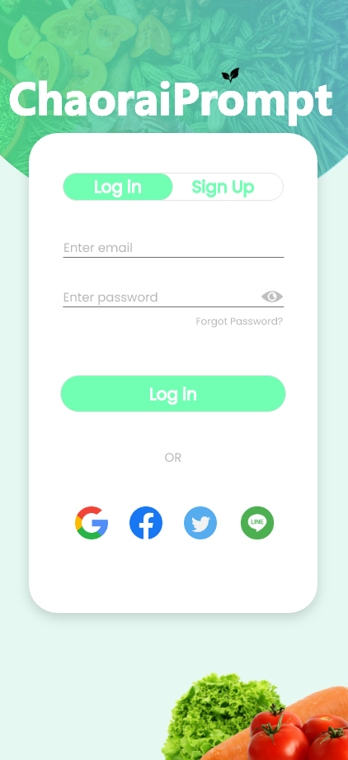 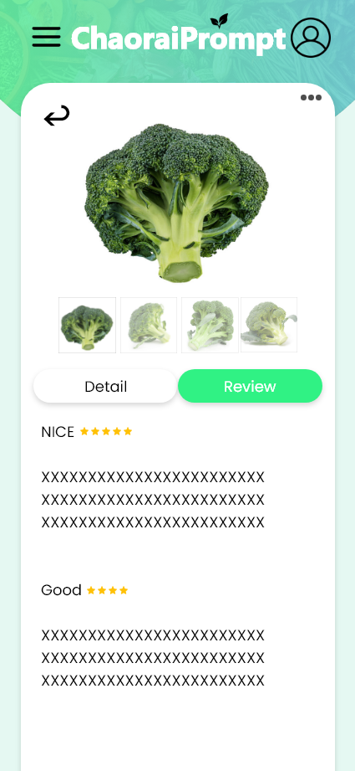 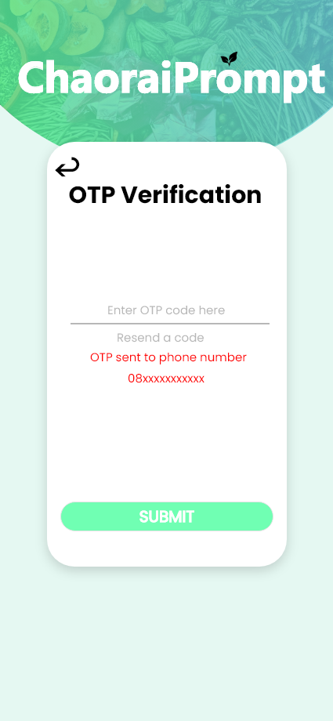

**Software Limitation**

* Cancel orders and refund product features
* Farmer store reliability features (Store reliability, review store from buyer)
* Admin revoke a farmer store license